AutoMark User Manual

**Developers:**

David Nobes

Logan McDonald, Summer 2017

Ivy Frieson, Winter 2018

Jehanzeb Mira, Summer 2019

David Shaw, Summer 2019

Owen Stadlwieser, Summer 2020

Pranj Patel, Summer 2021

Logan Vaughan, Summer 2021

**Authors:**

Owen Stadlwieser

Logan Vaughan

**Revised:**

2021-06-29

Table of Contents

1 Required Software 3

1.1 Microsoft Excel 3

1.2 SOLIDWORKS 3

1.3 MATLAB 3

1.3.1 MATLAB 3

1.3.2 Add-Ons 3

1.4 MiKTeX 3

1.4.1 MiKTeX 3

1.4.2 Packages 4

2 AutoMark Process 4

2.1 Launching AutoMark 4

2.2 Selecting the Student Folder 4

2.3 Unpacking the eClass Zip Folder 5

2.4 Running the Macros 5

2.5 Making/Loading Templates 6

2.6 Modifying Templates 6

2.6.1 Interface 6

2.6.2 Functionality 7

2.7 Running Marking 9

2.8 Packing the eClass Zip Folder 9

3 Creating a Marking Template 9

3.1 Making a Template 9

3.2 Modifying a Template 9

3.3 AutoMARK Criterion 10

3.4 Effects of changing criterion weights 12

3.5 Assignment Summary 13

3.6 Saving and Loading templates 13

4 Grading With AutoMARK 14

4.1 Running the grading process 14

4.2 Interpreting Student and Class reports 14

5 Overview of AutoMARK settings 15

5.1 Editing Report Settings 15

5.2 Editing Correction Settings 16

# Required Software

## Microsoft Excel

Microsoft Excel must be installed on your PC for AutoMark to work.

## SOLIDWORKS

SOLIDWORKS must be installed on your PC for AutoMark to work.

## MATLAB

### MATLAB

MATLAB must be installed on your PC for AutoMark to work. If you do not have MATLAB installed, go to <https://www.mathworks.com/downloads> and log in with your ualberta.ca email address. Then, you will be able to download MATLAB.

### Add-Ons

There are certain Add-Ons that need to be installed within MATLAB for AutoMark to work. In MATLAB, select the “HOME” tab and click on “Add-Ons”. Then, install these Add-Ons:

* Symbolic Math Toolbox
* Statistics and Machine Learning Toolbox
* Simulink
* Image Processing Toolbox
* 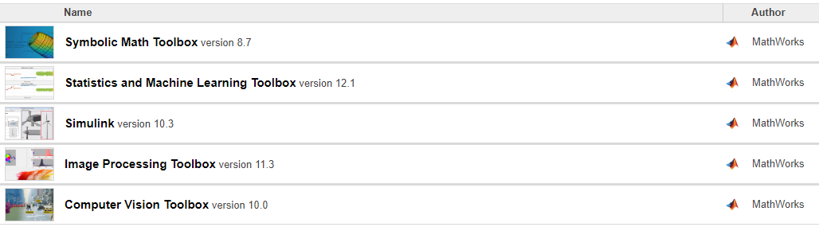Computer Vision Toolbox

Figure .1: This is an image of the required MATLAB Add-Ons from within the Add-On Manager.

## MiKTeX

### MiKTeX

MiKTeX must be installed on your PC for AutoMark to work. If you do not have MiKTeX installed, go to <https://miktex.org/download> . From there, you will be able to download MiKTeX.

### Packages

There are certain packages that need to be installed within MiKTeX for AutoMark to work. You will probably be prompted to install these packages when attempting to run the AutoMark marking process. If you are not automatically prompted, set a breakpoint on line 60 of createStudentPDF.m and run the marking process. When you try to step past line 62, you will be prompted to install all the required packages in MiKTeX (Note: there are a lot of packages).

# AutoMark Process

## Launching AutoMark

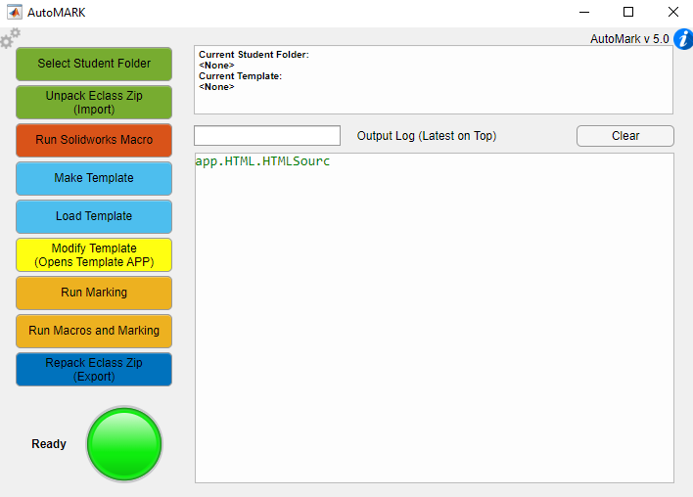In MATLAB, navigate to the AutoMark project folder. This folder is named “AutoMark”. This folder contains the entire AutoMark project. Then, enter “launch” into the Command Window (Note: this is equivalent to running launch.m). This will open the main GUI (which is a window named “AutoMark”).

Figure .1: This is an image of the main GUI.

## Selecting the Student Folder

The first thing you need to do is select a student folder. The student folder will contain all the student submissions and it is where all the graded submissions will be outputted. Press the “Select Student Folder” button and then choose an empty folder to be the student folder. After selecting a student folder, the path to that folder will be displayed on the main GUI in the top text box.

## Unpacking the eClass Zip Folder

An eClass zip folder is a zip folder from eClass that contains all the student submissions. To unpack one, press the “Unpack Eclass Zip (Import)” button and select the eClass zip folder. Then, check the student folder. It should now contain a folder and six subfolders for each student submission. Shown below is the format for an eClass zip folder (Note: AutoMark should be able to deal with zipped student submission folders inside the main zip folder).

*eClass Zip Folder >*

*Student1 submission folder >*

*SOLIDWORKS files submitted with Pack and Go*

*Student2 submission folder >*

*SOLIDWORKS files submitted with Pack and Go*

## Running the Macros

Basically, running the macros on SOLIDWORKS files extracts their data into excel files. Students submit SOLIDWORKS files for their assignments, so the excel files that the macros generate are important because they contain information that is used by AutoMark during the grading process. There is also one set of SOLIDWORKS files that acts as an answer key. Student submissions are graded based on their resemblance to the answer key. To run the macros, press the “Run Solidworks Macro” button. A window named “AUTOMACRO” will pop up.

To run the first macro, select “Export_Key_Drawing_Data” from under “Solidworks Macro”. Doing this selects the macro that generates the answer key’s excel file. Press “Select folder” and choose the folder that contains the SOLIDWORKS files that will be used as the answer key. Press “Run Macro” to run the macro. Then, check the selected folder. Now, it contains an additional folder containing an excel file and a single subfolder.

To run the second macro, select “Export_Class_Drawing_Data” from under “Solidworks Macro”. This selects the macro that generates the excel files for all the student submissions. Press “Select folder” and choose the student folder. Press “Run Macro” to run the macro. Then, check the student folder. Now, it contains an additional excel file in each student submission folder.

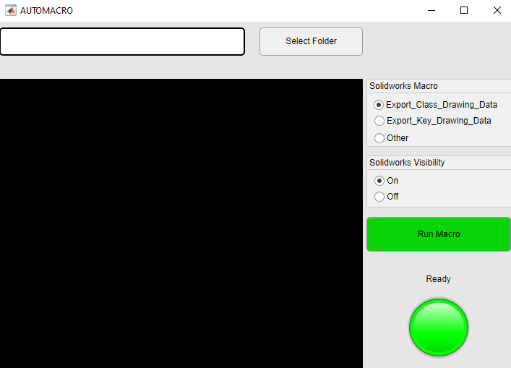After running both the macros, close the “AUTOMACRO” window.

Figure 2.2: This is an image of the “AUTOMACRO” window.

## Making/Loading Templates

If a template has already been created for this assignment, press the “Load Template” button, and select the template file. After selecting the template, its path should be displayed on the main GUI.

If there are no templates for the current assignment, press the “Make Template” button. Then, select the excel file that was created from the answer key. Then, the template will be created, and you will be prompted to save the template. After saving the template, its path should be displayed on the GUI.

## Modifying Templates

In this step, the template will be edited so that the assignment marks are distributed as desired. The template, having been made from the answer key’s excel sheet, basically is the answer key.

Press the “Modify Template (Opens Template APP)” button. This will open a window named “Modifying Template”. Also, the template path displayed in the main GUI will change to “<MODIFIED TEMPLATE>”. The path changes because the template being edited in the “Modifying Template” window is the same as the template being used in the marking process. So, all the changes made in the “Modifying Template” window are made directly on the template being used in the marking process. Furthermore, this template is its own instance and is not necessarily the same as the template that was originally made/loaded.

To make sure the right template is being used, save the template from the “Modifying Template” window after making the desired changes. Once it is saved, close the “Modifying Template” window, and load the recently saved template. This way, you will be able to see the file path for the template being used which helps make sure the right template is selected.

### Interface

Figure 4.1: This is an image of the “Modifying Template” window with annotations.

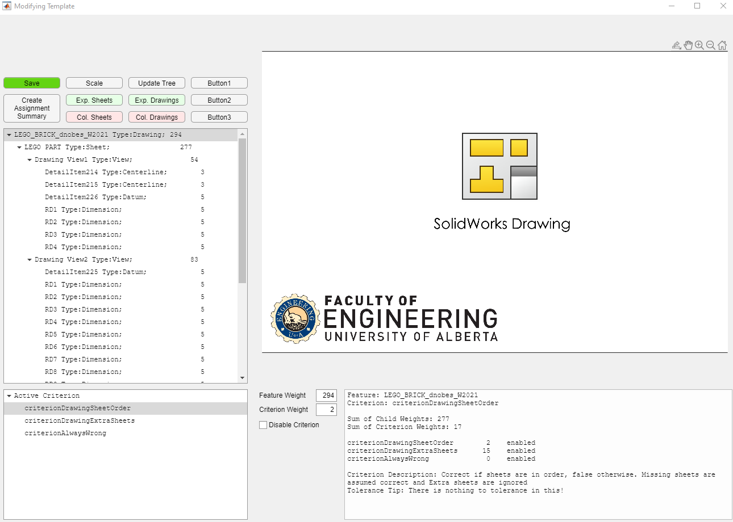

**Drawing Window**

**Feature Tree**

**Buttons**



**Fields**

**Criterion Tree**



**Information Box**



### Functionality

A template consists of the features that are displayed in the Feature Tree. The Feature Tree is just a tree where the nodes are the features from the template. Each feature has its own set of criterions, and its own weight. When a feature is selected from the feature tree, it will be displayed in the Drawing Window, its criterions will be displayed in the Criterion Tree, and its weight will be displayed in the “Feature Weight” field. The criterion selected from the criterion Tree will display its weight in the “Criterion Weight” field. Additional fields may appear depending on which criterion is selected. The Information Box also contains some relevant information.

Each assignment uses the node of type “Drawing” as the parent node. The feature weight of this node is the total of the assignment. This node will have one or more children. Its children are the Sheets. The children of the Sheets are the Views, and the children of the Views are the Dimensions, Centerlines, etc. When a feature weight is changed, the feature weights of its parent nodes will be recalculated. This recalculation is just a summation of the children’s feature weights. So, make sure to edit the template from the children towards the parents.

The assignment marks are calculated by subtracting the criterion weights of incorrect criterions from the feature weights of the features they correspond to. The marking is done like this so that certain criterions can be easily disabled by setting their weight to zero (checking the “Disable Criterion” box achieves the same effect), and so that a certain criterion could reduce the mark of a feature to zero if the student gets it wrong (this is done by setting the criterion weight to the feature weight). Of course, the lowest a student can score on a feature is zero (no negative marks). This means that the sum of the criterion weights may be higher than the feature weight.

It is worth noting that the feature weights of features that have children should be summations of their children’s feature weights plus whatever feature weight is being assigned to feature itself. So, all the program’s recalculations should not be final because they are just summations of the children’s feature weights. Also, this means that the sum of the criterion weights may be lower than the feature weight of features that have children.

Functionality of the Feature Tree:

Contains all the features and displays their feature weights.

Functionality of the Criterion Tree:

Contains the criterions of the selected feature.

Functionality of the Drawing Window:

Displays the part of the SOLIDWORKS drawing that corresponds to the selected feature.

Functionality of the Fields:

The fields are used for making edits to the template.

Some of the criterions are marked depending on how close something is to its position in the answer key. The Xmax, Xmin, Ymax, Ymin, R, and T exist to adjust this margin of error.

* Feature Weight: Changes the feature weight.
* Criterion Weight: Changes the criterion weight.
* Disable Criterion: Disables the criterion.
* Xmax: For editing the dimensions of a criterion.
* Xmin: For editing the dimensions of a criterion.
* Ymax: For editing the dimensions of a criterion.
* Ymin: For editing the dimensions of a criterion.
* R: For editing the dimensions of a criterion.
* T: For editing the dimensions of a criterion.

Functionality of the Information Box:

Contains the criterion weights and whether they are disabled. Also contains other useful information.

Functionality of the Buttons:

* Save: Saves the modified template.
* Create Assignment Summary: Saves a summary of the marking scheme.
* Scale: Adjusts the scale of the SOLIDWORKS drawing in the Drawing Window.
* Update Tree: Deletes the old Feature Tree and creates a new one.
* Exp. Sheets: Expands the sheets in the Feature Tree.
* Exp. Drawings: Expands the drawings in the Feature Tree.
* Col. Sheets: Collapses the sheets in the Feature Tree.
* Col. Drawings: Collapses the drawings in the Feature Tree.
* Button1: Reserved for future functionality.
* Button2: Reserved for future functionality.
* Button3: Reserved for future functionality.

## Running Marking

Now that the template and student folder have been set up, press the “Run Marking” button to run the marking process. After the marking process is finished, check the student folder. The subfolders of each submission should now be populated. Additional information is provided in Section 4.

## Packing the eClass Zip Folder

After the marking process is done, press the “Repack Eclass Zip (Export)” button. This will prompt you to save a zip file. This zip file contains the grades of each student, and it will be submitted to eClass.



# Creating a Marking Template

This section explains the same things as section 2.6, but at a different level of detail. This section was written before version 5.0, so parts of it may be outdated.

## **Making a Template**

A marking template is a SOLIDWORKS drawing file that assigns weights to different features. Student submissions are compared with the marking key and given a grade based on well they replicate it. To create a marking key, press the “Make Template” button and select the excel file generated from running the key macro on the assignment solution. The marking template is generated using the default weights for criterion which can be seen in Table 2.1.

## **Modifying a Template**

Pressing the yellow “Modify Template” button will launch the modify template user interface (Note: the GUI described in this section is outdated).

Figure 3.1: An example of a marking template opened in the modify template user interface. This GUI is now outdated.

On the left-hand side there are controls for navigating the template. The cycle through template buttons allow to quickly jump from one feature to the next. The following tree uses a point and click method to navigate the template. This tree works in the same manner as the solid works feature manager and is the recommended way to navigate through a marking key. The second tree demonstrates all the criterion within a feature, criterions are essentially what gets graded. Once a criterion is selected all its information will appear in the text and edit boxes on the bottom. The criterion weight is how many marks will be deducted if the criterion is deemed incorrect. The feature weight is how many total marks can be deducted from the feature which encompasses the criterion.

## **AutoMARK Criterion**

Each Solidworks feature contains their own set of criterions in AutoMARK. The weight of the criterion determines the deduction that will be taken from the feature weight if the criterion is deemed incorrect. The criterion weights can be altered in the Modify Template user interface.

Table 3.1: This table demonstrates all the current AutoMARK criterion, their default weight, and an explanation as to how they are graded. This table is correct as of version 5.0.

|  |  |  |
| --- | --- | --- |
| Criterion | Default Weight | Description |
| Drawing Sheet Order | 2 | Correct is students’ sheets are in the same order as key. |
| Drawin Extra Sheets | 15 | Correct if there are no extra sheets |
| SheetName | 0 | Correct if sheet name matches key |
| SheetPaperSize | 1 | Correct if paper size matches key |
| SheetScale(1) | 1 | Correct if sheet scale matches key |
| SheetTemplate(1) | 1 | Correct if template matches key |
| SheetExtraBOMS(15) | 15 | Correct if there are no extra BOMS |
| SheetExtraViews(15) | 15 | Correct if there are no extra views |
| SheetViewTypes(15) | 10 | Correct if the student has the same amount of each view type as the key (example: 2 dragged in views, 1 projected) |
| SheetIntersectingBallons(5) | 5 | Correct if there are no intersecting ballons |
| BOMTableType(40) | 40 | Correct if the table type matches key |
| BOMContent | 3 | Correct if half the content matches key |
| BOMColumnOrder | 8 | Correct if column order matches key |
| BOMNumberColumns(10) | 6 | Correct if BOM has the same number of columns as key |
| BOMNumberRows(10) | 6 | Correct if BOM has the same number of rows as key |
| BOMPosition(10) | 10 | Correct if BOM is snapped to corner |
| BOMTableHeight(2) | 2 | Correct if BOM has same table height as key |
| BOMTableWidth(2) | 2 | Correct if BOM has same table width as key |
| BOMFontType(2) | 1 | Correct if BOM has the same font in all cells as the key |
| BOMFontSize(2) | 1 | Correct if BOM has the same font size in all cells as the key |
| ViewScale(2) | 2 | Correct if view is of the same scale as the key |
| ViewTangentLines | 3 | Correct if tangent line style matches key |
| ViewDisplayStyle(1) | 1 | Correct if view is of the same display style as the key |
| ViewExtraDimension(1) | 1 | Correct if view does not have extra dimensions |
| ViewPosition(3) | 6 | Correct if view position is within key tolerance box |
| ViewExtraCentermarks(1) | 1 | Correct if view does not have extra centermarks |
| ViewMass(1) | 1 | Correct if view has the same mass as the key |
| ViewMaterial(3) | 3 | Correct if view uses the same material as the key |
| ViewExtraDatums(1) | 1 | Correct if view does not have extra datums |
| ViewWrongProjection(3) | 3 |  |
| ViewExtraCenterlines(1) | 1 | Correct if view does not have extra centerlines |
| criterionFeatureDangling(2), | 2 | Correct if feature is attached to something |
| criterionDimensionWrongView(2), | 2 | Correct if dimension is not on the wrong view |
| criterionDimensionPostion(1), | 1 | Correct if dimension position is within tolerance box |
| criterionDimensionArrowSide(1), | 1 | Correct if dimension arrows are on the same side as the key |
| criterionDimensionValue(2), | 2 | Correct if the dimension value is the same as the key |
| criterionDimensionBadText(2) | 2 | Correct if the dimension text matches the key |
| criterionCenterlinePostion(1) | 1 | Correct if the centerline position is within the key tolerance box |
| criterionCentermarkPosition(3), | 3 | Correct if the centermark position is within the key tolerance box |
| criterionCentermarkStyle(2), | 2 | Correct if the centermark is of the same style as the key |
| criterionCentermarkShowlines(1), c | 1 | Correct if centermark showlines matches others showlines |
| criterionCentermarkAngle(1), | 1 | Correct if angle matches key |
| criterionCentermarkConnectionLines(1), | 1 | Correct if connection lines match key |
| criterionCentermarkExtensions(1), | 1 | Correct if key and student submission are extended |
| criterionCentermarkGap(1), | 1 | Correct if within gap rectangles |
| criterionCentermarkMarkSize(1), | 1 | Correct if the centermark is of the same size as the key |
| criterionCentermarkGroupedCorrectly(1) | 1 | Correct if the centermarks are grouped the same as the key |
| criterionFeatureDangling(2), | 2 | Correct if datum is on the same view as it is in the key |
| criterionDatumPostion(1), | 1 | Correct if datum position is within key tolerance box |
| criterionDatumBasePosition(1), | 1 | Correct if datum base position matches key |
| criterionDatumLabel(2), | 2 | Correct if datum label is the same as it is in the key |
| criterionDatumDisplayStyle(1), | 1 | Correct if display style matches key |
| criterionDatumFilledTriangle(1) | 1 | Correct if triangle fill style matches key |
| criterionBallonPosition(2) | 0 | Correct if balloon position is within key tolerance box |
| criterionAlwaysWrong | 0 | This criterion is always correct, and the weight given will be added to the students total marks on the parent feature |

## **Effects of changing criterion weights**

Criterion weights can be viewed and changed in the Modify Template user interface. Changing criterion weights will not increase the weight of the parent feature, it will only increase the penalty for the criterion mistake. To increase the overall weight of the parent feature, the feature weight must be edited. Feature weights can be edited from the modify template interface or the settings user interface. If a feature weight exceeds the sum of the criterion weights students essentially get free marks. Proportionally increasing a feature weight and its criterion weights will cause it to be worth a greater proportion of the assignment.

One special criterion is the CriterionAlwaysWrong criterion. Each feature contains this criterion, and it has a default weight of zero. If this criterion is assigned a weight, it will give a boost to the students score on the corresponding feature. For example, if the grading on one sheet is stricter than the grader wishes, assigning the CriterionAlwaysWrong criterion a weight of 5% of the overall sheet score will act as a 5% leniency.

## **Assignment Summary**

The assignment summary tool is a new tool designed to help markers create rubrics for their assignments. The assignment summary tool will prompt the user for the total grades to disperse across the assignment. It will then create a summary as seen in Figure 3.2 with marks assigned in accordance with the AutoMARK score. Using this tool to create the rubric for each assignment will greatly increase the likelihood that the AutoMARK grade and TA grades are in relative agreement. To create an assignment summary, press the Create Assignment button that can be found in the bottom right of the Modify Template user interface as seen in Figure 3.1 (this button is in the top left corner as of version 5.0). The following figure is an example of an Assignment Summary for an assignment with a total of 40.

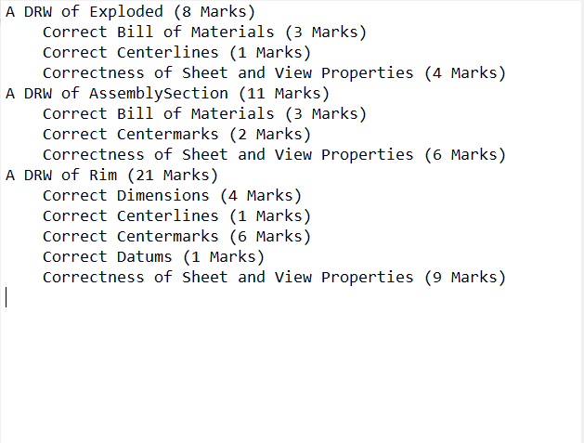

Figure .2: An example of an assignment summary.

## **Saving and Loading templates**

Using the green save button in the Modify Template user interface it is possible to save a grading template. Templates are saved and loaded as .mat files and will preserve user defined criterion and feature weights.

# Grading With AutoMARK

AutoMARK can be used as solely a markup tool or mark up and grading tool. For each student AutoMARK will produce a fully marked up drawing, an AutoMARK score, and a recommended grade.

## **Running the grading process**

To run the grading process, press the “Run Marking” button on the main GUI. If you want to run the class macro and then the grading process at the same time, press the “Run Marking and Macros” button.

## **Interpreting Student and Class reports**

Once the grading has completed there are four documents the instructor should be aware of. The first document produced is a pdf report which features all the students submitted drawing sheets, the mark up of their drawing sheets, and the assignment solution. At the University of Alberta this document is reuploaded to Eclass where the students can view the markup of their drawing and learn from their mistakes. The second document is an excel sheet titled “Marking Scores ‘current date’” this excel sheet contains all students’ names, AutoMARK scores, whether their submissions were unique, what files they submitted, the time it took to mark, and whether it was successfully marked. The third document produced is a class report pdf which features histograms of the AutoMARK scores of each sheet and of the entire assignment. The class report also has a list of students that received a score under 50%. The final document is a marking log which contains a list of which files were marked and where AutoMARK was unsuccessful.

# Overview of AutoMARK settings

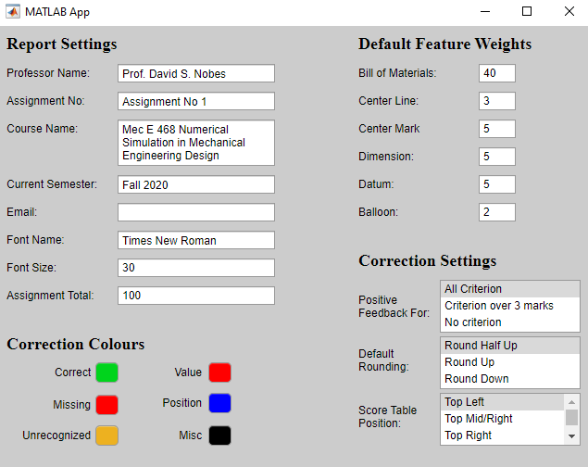The AutoMARK settings GUI provides the user with control over report and grading details. The user can access the settings GUI by clicking on gear image in the top left corner of the main GUI.

Figure .1: This is an image of the settings GUI.

## **Editing Report Settings**

The report settings allow the user to quickly change details concerning the style of the PDF returned to students. For example, Professor Name, Assignment No, Course Name, Current Semester, Font Name, and Font Size are all display settings where changes will affect the outputted pdf. When marking is completed, the app will send an email to the email in the email setting box. The assignment total setting is the number that the autoMARK score will be scaled to, this creates a more comprehensible grade.

## **Editing Correction Settings**

Correction settings can be broken up into three main groups: Default Feature Weights, Correction Colours, and Correction Settings.

The Default Feature Weights control the weight of features when a new template is created. There are no views, sheets, or drawings in this list because their weights default to the sum of their criterion and their child feature weights. Editing a feature weight will not change the value of any criterion so, if the center mark weight changes from 5 to 6, criterion deductions will be worth a smaller portion of the overall grade.

The Correction Colours control the appearance of the outputted pdf. For example, when a student makes a value error, the correction will be written in whatever colour the user choses to associate with value, and events that result in positive feedback will be written in the colour is associated with correct.

The Correction Settings control parts of the student report and how AutoMARK calculates it is recommended grade. The Positive Feedback For setting either suppresses or allows written positive feedback for some criterion. Suppressing this will not suppress checkmarks on fully correct features. The Default Rounding setting decides how AutoMARK calculates its recommended grade. Half round up is conventional rounding, round up means a 3.1 would round to a 4, and round down means a 3.9 would round to a 3. The Score Table Position setting sets the position of the score table on the student reports. This setting allows the user to choose the ideal position for the score table to be printed (ideal positions may vary from assignment to assignment).